**Pizza sales SQL-queries and outputs:**

**A. KPI’s**

**1.Total Revenue**

SELECT SUM(total_price) AS Total_Revenue from pizza_sales;

*Output:*

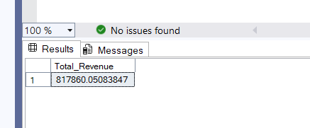

**2.Average Order Value**

SELECT SUM(total_price) / COUNT(DISTINCT order_id) as Avg_Order_Value from pizza_sales

*Output:*

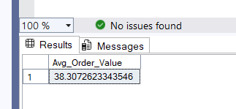

**3.Total Pizza Sold**

SELECT SUM(quantity) AS Total_Pizza_Sold from pizza_sales

*Output:*

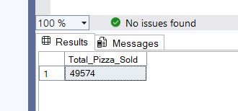

**4.Total Orders**

SELECT COUNT(DISTINCT order_id) AS Total_orders from pizza_sales

*Output:*

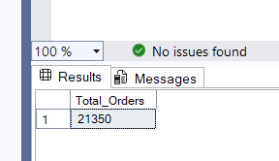

**5.Average pizzas per order**

SELECT CAST(CAST(SUM(quantity) AS DECIMAL(10,2)) / CAST(COUNT(DISTINCT order_id) AS DECIMAL(10,2)) AS DECIMAL(10,2)) AS Avg_Pizzas_per_order from pizza_sales

*Output:*

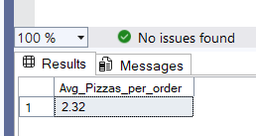

**B. SALES INSIGHTS**

**DAILY TREND FOR TOTAL ORDERS-**

SELECT DATENAME(DW, order_date) as order_day, COUNT(DISTINCT order_id) AS Total_orders from pizza_sales GROUP BY DATENAME(DW,order_date)

*Output:*

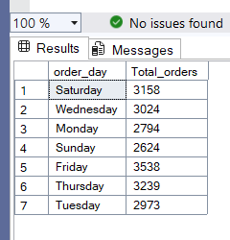

**MONTHLY TREND FOR TOTAL ORDERS-**

SELECT DATENAME(MONTH, order_date) AS Month_name, COUNT(DISTINCT order_id) AS Total_Order FROM pizza_sales GROUP BY DATENAME(MONTH, order_date) ORDER BY Total_Order DESC

*Output:*

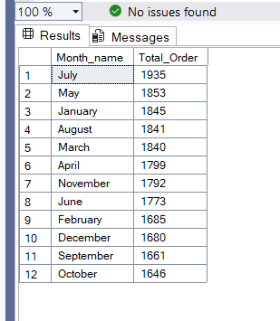

**PERCENTAGE OF SALES BY PIZZA CATEGORY**-

SELECT pizza_category, sum(total_price) * 100 / (SELECT sum(total_price) AS Total_Sales_percentage from pizza_sales) from pizza_sales GROUP BY pizza_category

*Output:*

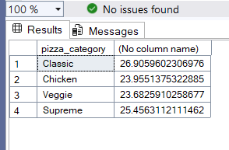

**PERCENTAGE SALES BY PIZZA SIZE-**

SELECT pizza_size, CAST(SUM(total_price) AS DECIMAL(10,2)) as total_revenue,

CAST(SUM(total_price) * 100 / (SELECT SUM(total_price) from pizza_sales) AS DECIMAL(10,2)) AS PCT

FROM pizza_sales

GROUP BY pizza_size

ORDER BY pizza_size

*Output:*

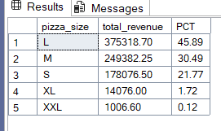

**TOTAL PIZZA SOLD BY PIZZA CATEGORY-**

SELECT pizza_category, SUM(quantity) as Total_Quantity_Sold

FROM pizza_sales

WHERE MONTH(order_date) = 2

GROUP BY pizza_category

ORDER BY Total_Quantity_Sold DES

*Output:*

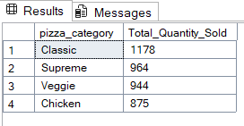

**Top 5 Pizzas by Revenue**

SELECT Top 5 pizza_name, SUM(total_price) AS Total_Revenue

FROM pizza_sales

GROUP BY pizza_name

ORDER BY Total_Revenue DESC

*Output:*

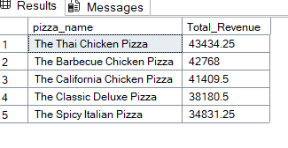

**Bottom 5 Pizzas by Revenue**

SELECT Top 5 pizza_name, SUM(total_price) AS Total_Revenue

FROM pizza_sales

GROUP BY pizza_name

ORDER BY Total_Revenue ASC

*Output:*

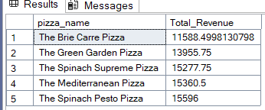

**Top 5 Pizzas by Quantity**

SELECT Top 5 pizza_name, SUM(quantity) AS Total_Pizza_Sold

FROM pizza_sales

GROUP BY pizza_name

ORDER BY Total_Pizza_Sold DESC

*Output:*

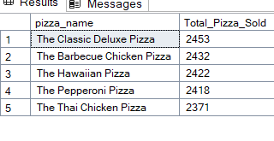

**Bottom 5 Pizzas by Quantity**

SELECT TOP 5 pizza_name, SUM(quantity) AS Total_Pizza_Sold

FROM pizza_sales

GROUP BY pizza_name

ORDER BY Total_Pizza_Sold ASC

*Output:*

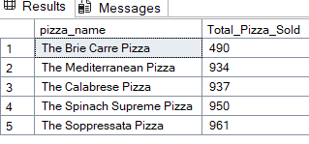

**Top 5 Pizzas by Total Orders**

SELECT Top 5 pizza_name, COUNT(DISTINCT order_id) AS Total_Orders

FROM pizza_sales

GROUP BY pizza_name

ORDER BY Total_Orders DESC

*Output:*

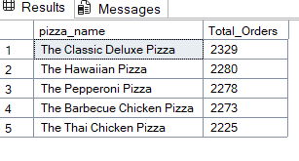

**Bottom 5 Pizzas by Total Orders**

SELECT Top 5 pizza_name, COUNT(DISTINCT order_id) AS Total_Orders

FROM pizza_sales

GROUP BY pizza_name

ORDER BY Total_Orders ASC

*Output:*

